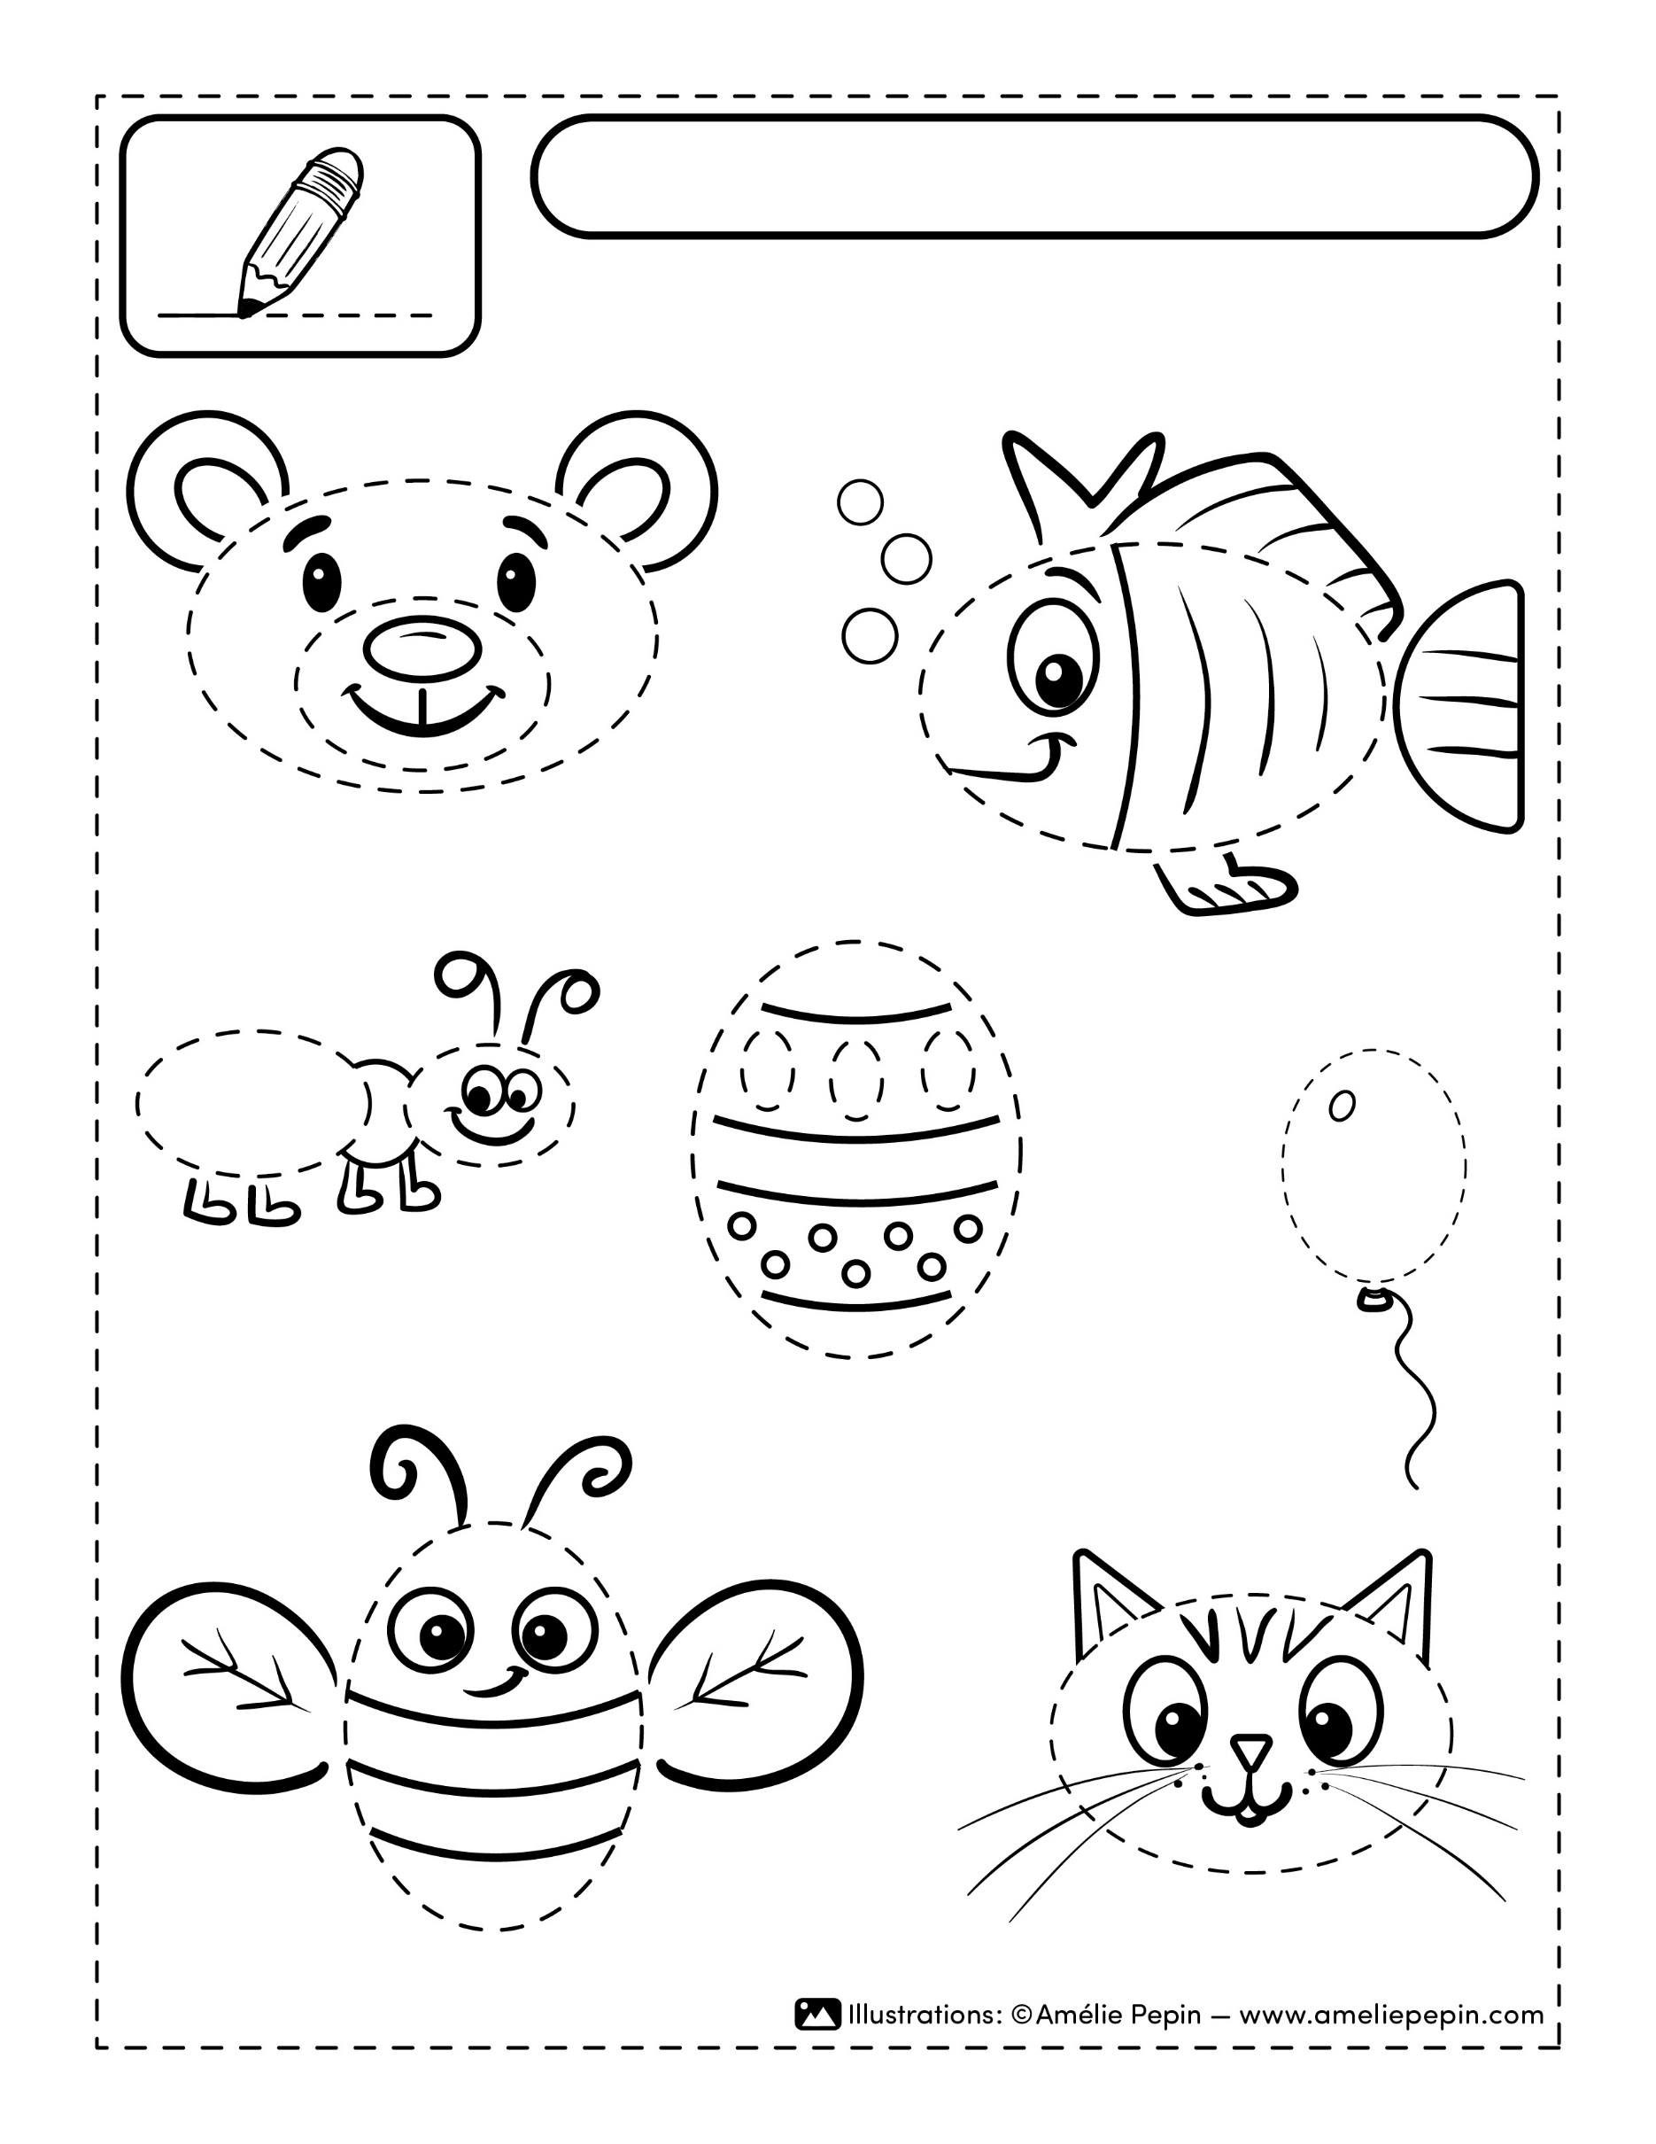
Your text here.
Your text here.
Your text here.
Your text here.
Your text here.
Your text here.
Your text here.
Your text here.
Name :

